Aim: To Perform BI using Tableau

Theory:

Q1. Explain Tableau.
Tableau is a smart tool that turns boring numbers and data into clear, visual stories.
It connects to almost any data source you have—like Excel files, databases, or online apps—and lets you build interactive charts, maps, and dashboards just by dragging and dropping. You don’t need to be a programmer.
The whole point is to help people and companies quickly see what’s happening in their data, spot trends, and make smarter decisions without getting lost in complex spreadsheets.
Because it's both easy to use and powerful, Tableau helps teams ask better questions, find answers faster, and share discoveries with anyone, in a way that everyone can understand.

Q2. List Features of Tableau.
- Data Blending: Combine data from multiple sources into a single view.
- Real-Time Analysis: Connect to live data for up-to-the-second insights.
- Collaboration: Share dashboards and work together via Tableau Server/Cloud.
- Drag-and-Drop Interface: Build visualizations without coding.
- Interactive Dashboards: Create clickable, filterable reports.
- Wide Data Connectivity: Link to databases, cloud apps, spreadsheets, etc.
- Advanced Analytics: Integrate trends, forecasts, and statistical summaries.
- Mobile Responsiveness: Access and view dashboards on any device.
- Scalability: Handle large datasets and enterprise deployments.

Q3. List Applications of Tableau.
- Business Intelligence & Reporting: Automating and distributing KPI dashboards for sales, finance, and operations.
- Data Exploration & Discovery: Allowing analysts to interactively explore datasets to find hidden patterns and insights.
- Performance Monitoring: Tracking real-time metrics across departments like marketing campaigns or website traffic.
- Geospatial Analysis: Creating maps to visualize regional sales, delivery routes, or demographic data.
- Trend Forecasting: Using built-in statistical models to predict future sales, inventory needs, or customer behaviour.
- Executive Dashboards: Providing leadership with a high-level, interactive overview of organizational health.
- Public Data Storytelling: Governments and NGOs use it to make complex data (e.g., budgets, census info) publicly accessible and understandable.

Q4. Which Data Set is being used?
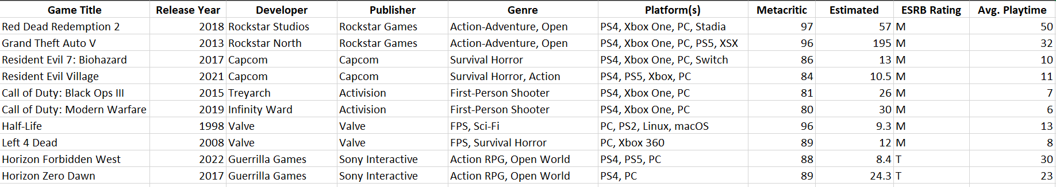

Pie Chart: (Publisher X Average Playtime X Estimated Sales)
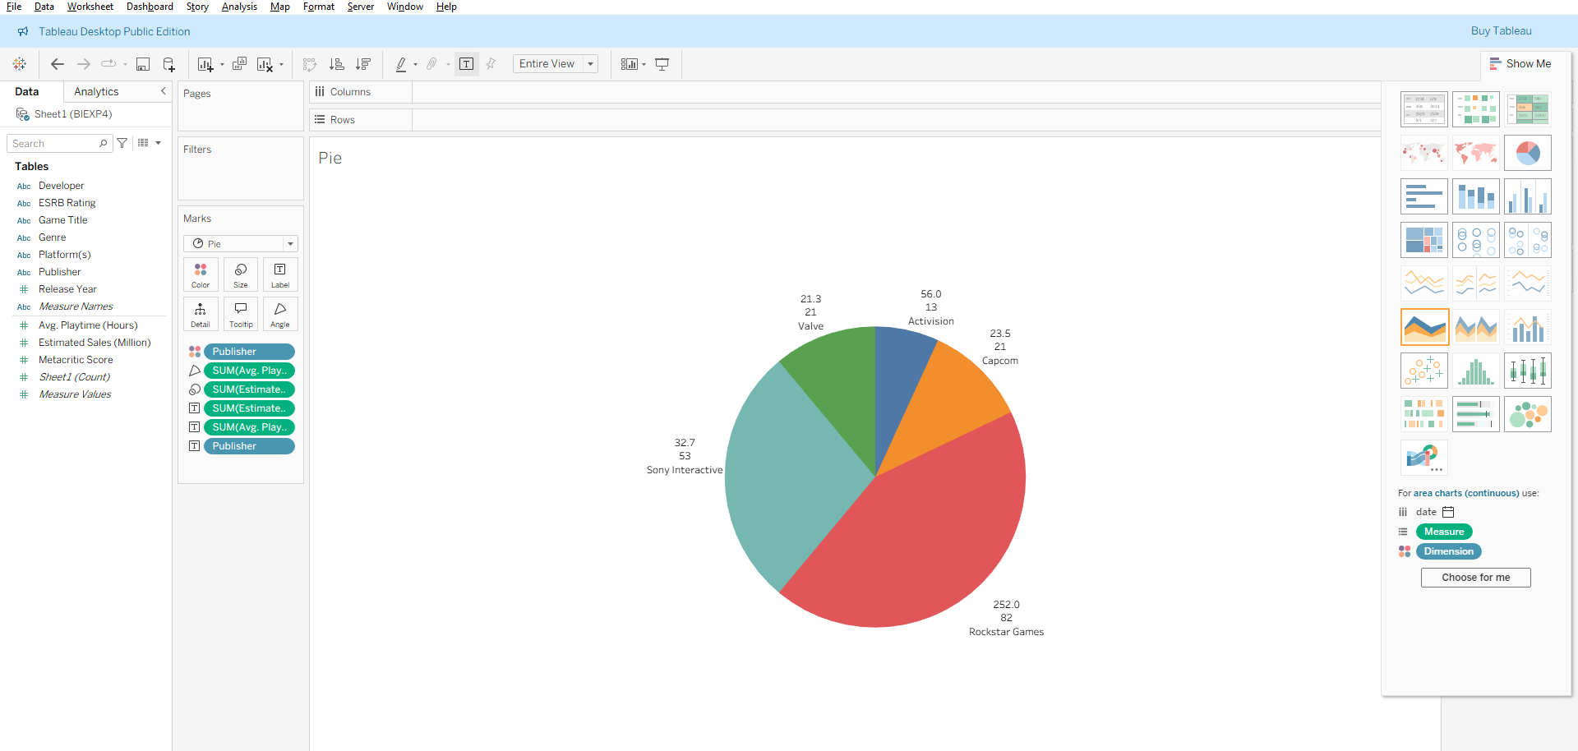

Horizontal Bar Graph: Average Playtime X Developer
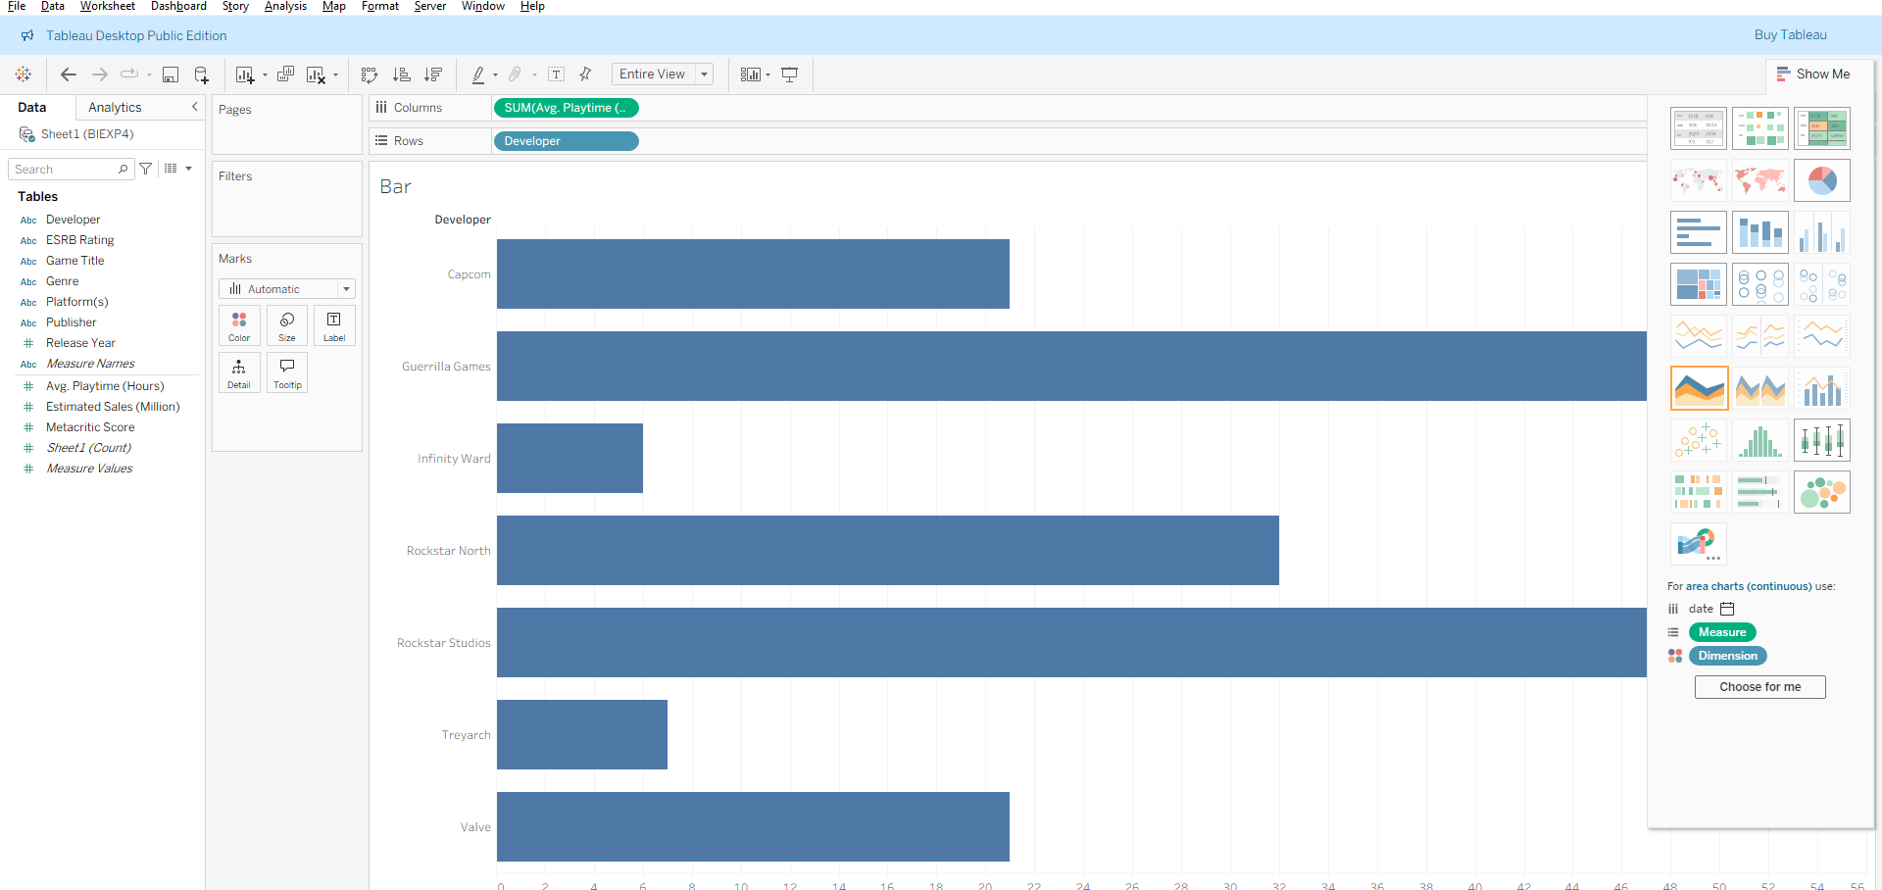

Scattershot: Release Year X Average Playtime
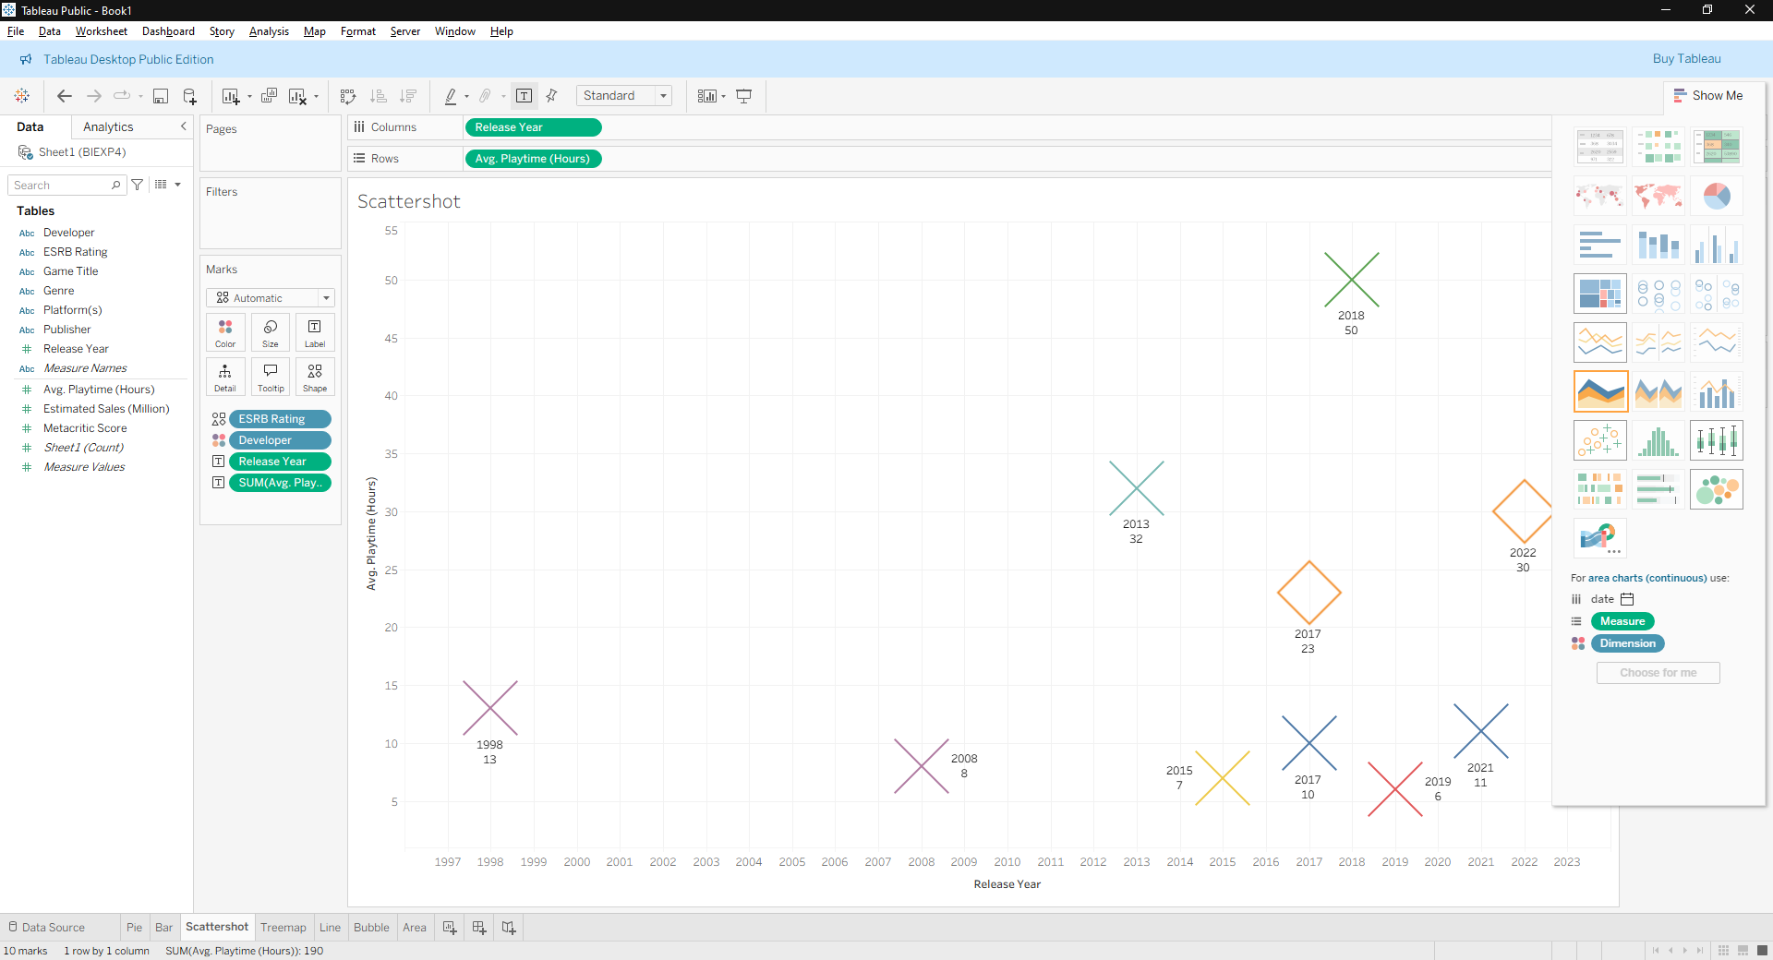

Tree map: Developer X Estimated Sales
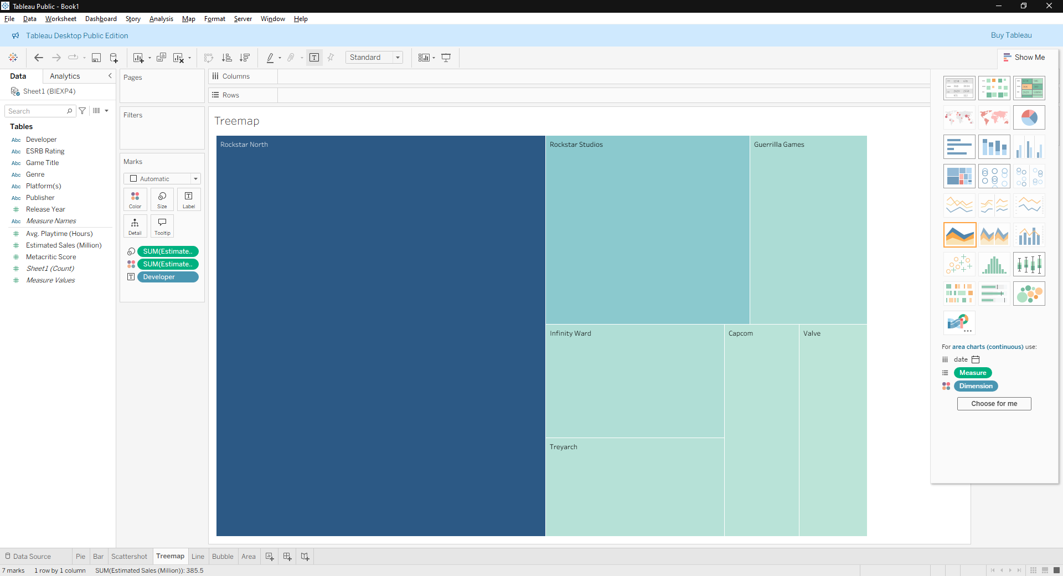

Line Chart: Release Year X Estimated Sales
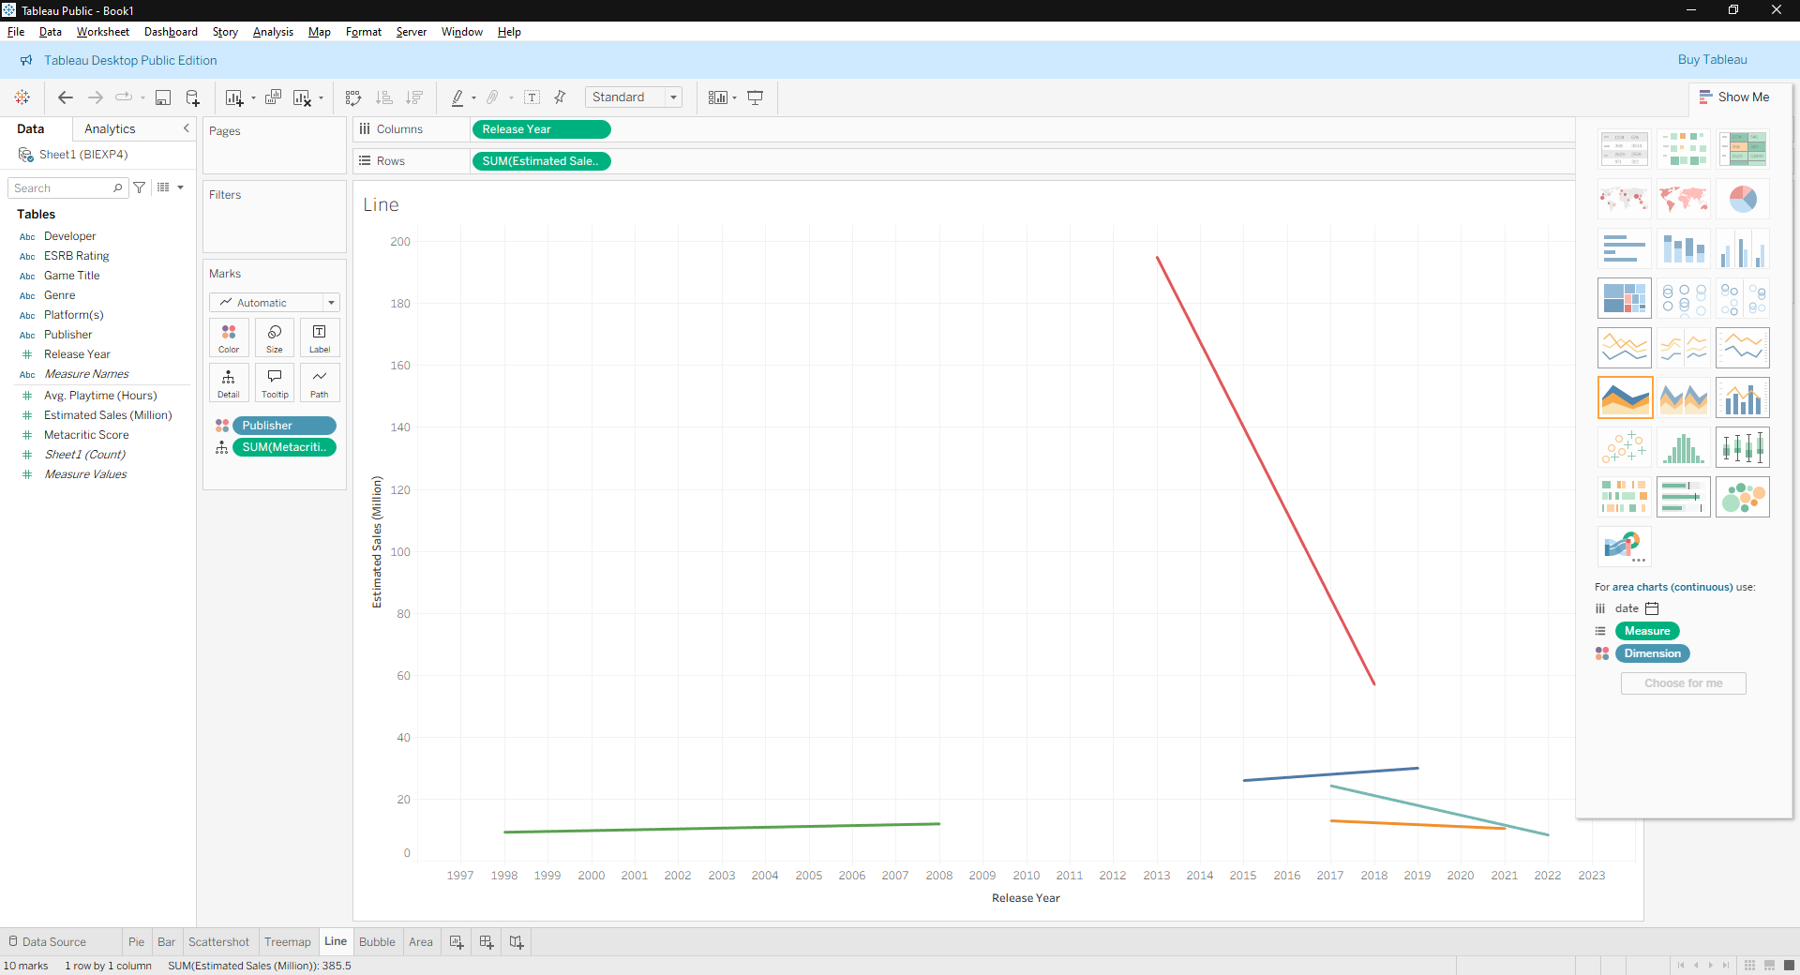

Bubble Chart: Developer X Estimated Sales
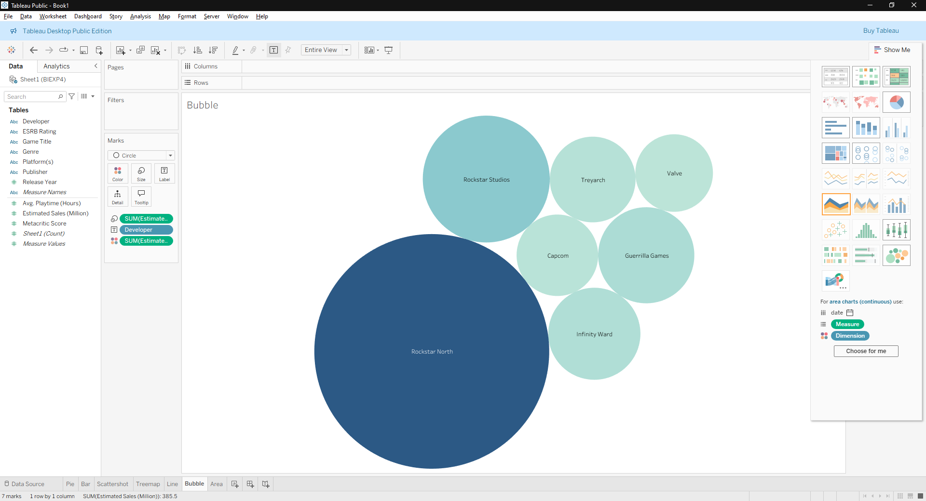

Area Continuous Graph: Metacritic Score X Estimated Sales
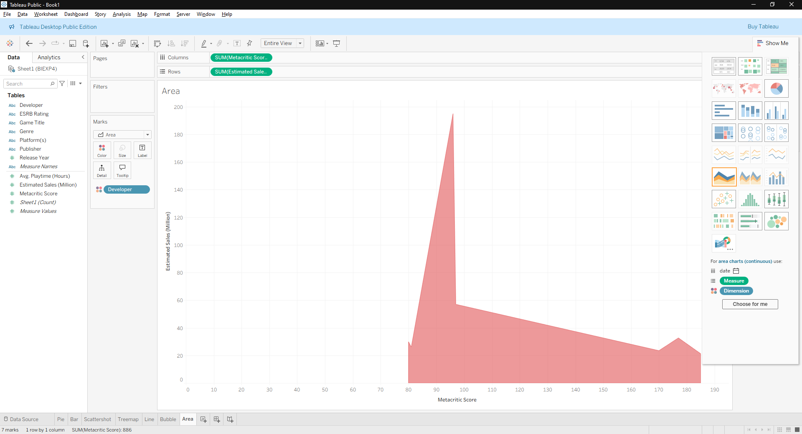

Custom Dashboard of all graphs used:
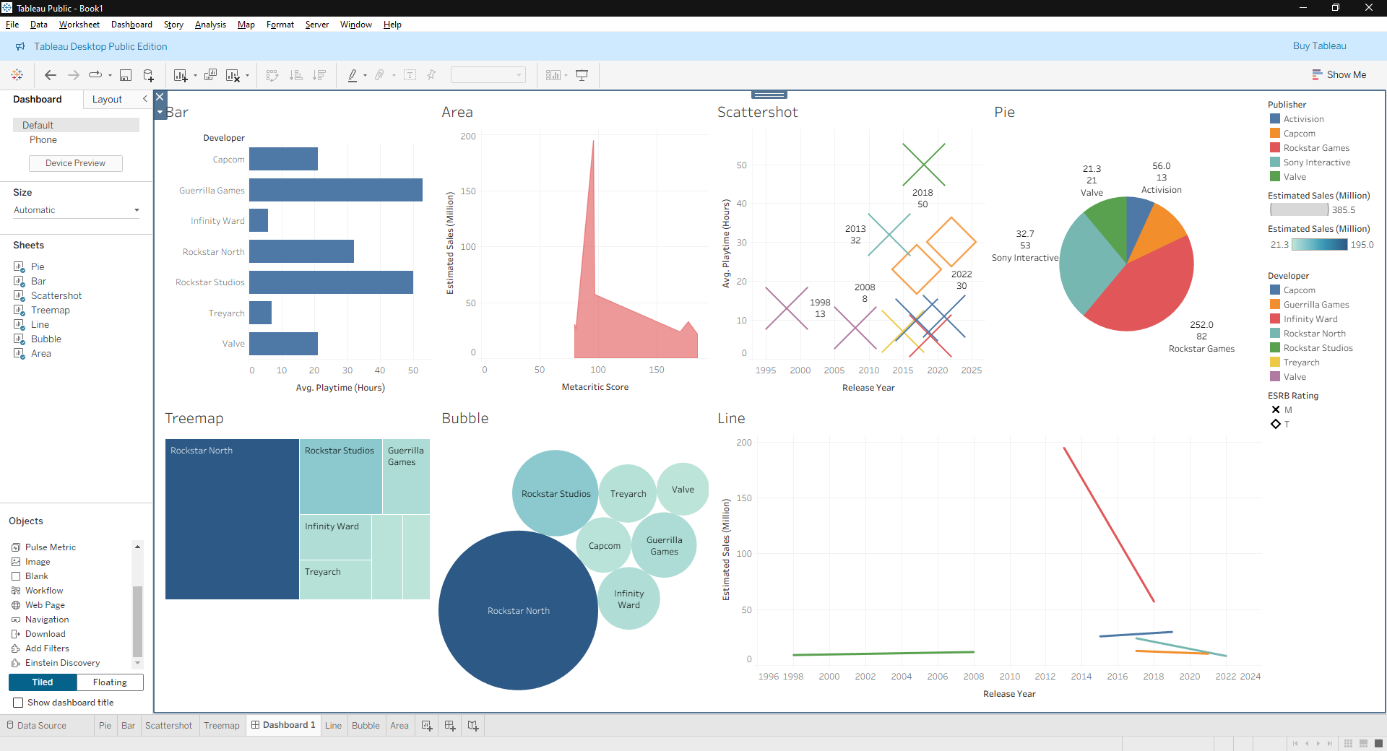

Conclusion
Tableau effectively transforms raw data into actionable insights through interactive visualizations and dashboards, empowering users to identify trends, make informed decisions, and communicate findings clearly and efficiently.

